* HPI timeline?
* Comparing multiple life expectancy “functions” including “ours” and from other packages
* Age groups
  + USA-LEEP
    - 11 age groups, 0, 1-4, 5-14, …. 75-84, 85+
    - 2010 decennial + 2011-2015 ACS; ACS does not have 0 separated out from 1-4?
  + (CCB county – 19 age groups)
  + (MSSA – 18 age groups (0 and 1-4 combined))
* Exact “Met the mortality schedule criterion” approach unclear
* Starting replication of modeling to fill in tracts with any 0 deaths in any age group
  + Using 2010 tracts and 2015-2019 ACS data for now
* Little work on 2010 to 2020 tract mapping
  + <https://www.nhgis.org/geographic-crosswalks>
* No review yet of nearest neighbor methods
  + R resources for geographic nearest neighbor imputation:
    - [spdep package](https://urldefense.com/v3/__https:/cran.r-project.org/web/packages/spdep/index.html__;!!AvL6XA!1bkJBb7q3X2wsGNSaO9vMNWf6wSEA4X4NJCeywn3F2JqQV2Zt_QIAOjJjTiw5vZhU8DlAjx1UX3C120rWLNd$)
    - [spatialEco package](https://urldefense.com/v3/__https:/cran.r-project.org/web/packages/spatialEco/index.html__;!!AvL6XA!1bkJBb7q3X2wsGNSaO9vMNWf6wSEA4X4NJCeywn3F2JqQV2Zt_QIAOjJjTiw5vZhU8DlAjx1UX3C1xJND4U4$)
    - [R Spatial Data Science](https://urldefense.com/v3/__https:/r-spatial.org/book/14-Areal.html__;!!AvL6XA!1bkJBb7q3X2wsGNSaO9vMNWf6wSEA4X4NJCeywn3F2JqQV2Zt_QIAOjJjTiw5vZhU8DlAjx1UX3C1z_6Iq7K$) book
* “Snag” continues with get lon/lat
* NO progress or discussion on improving geocoding
* 467 (5.8%) of 8013 tracts have no zeros

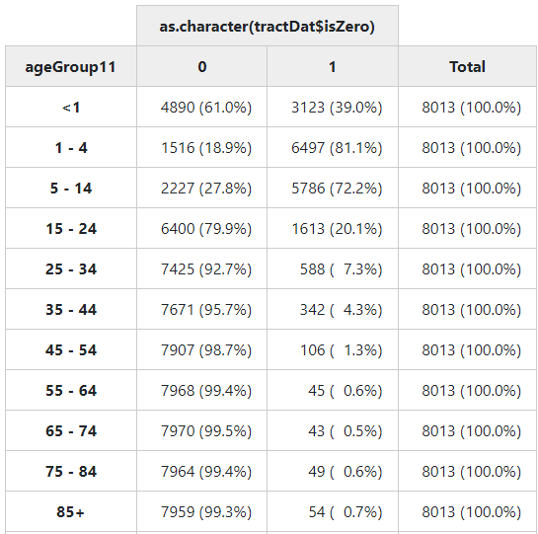

**Core Life expectancy work**

* **File 1**
  + **Get death data**
  + **Get population data**
* **File 2**
  + **Link death and pop data**
  + **Wrangle into format need for life table function**
* **File 3**
  + **Our life table function**
* **File 4**
  + **Running LT function and generating output**
    - **LE at birth**
    - **Full table?**
* **“Parameters”/info**
  + **“a” values (average fraction of interval lived)**
  + **Different age groups (always use ageLink)**
  + **Different calendar year periods (1, 5, 6?)**
    - **2000 to current for 1-year state and county**
    - **? 2018-2022 – CCB**
    - **2019-2023 - special**
  + **Race option (always use raceLink)**
  + **Sex option**
  + **State, county, LHJ, tract, MSSA**

**HPI project and testing**

* **Run our function and LT functions from other packages and compare for testing**
* **Small area analysis code and work**

**(threshold values)**

**(tract denominator source)**

* **Life Table Calculation**
  + **createPopData_for_ltmaker.R**
    - Produces state, county, and MSSA-level population data which are then used in “ltmaker.R” to calculate life tables
    - Inputs:
      * lhj-population-ars-le.RDS - DOF LHJ level population data dating back to 2000
        + 2000-2009: California and Counties Population by Age, Race/Hispanics, and Gender: 2000-2010 - <https://dof.ca.gov/forecasting/Demographics/estimates/>
        + 2010-2019: Complete State and County Projections (Table P-3) - <https://dof.ca.gov/forecasting/demographics/Projections/>
      * nxMSSA.RDS - Last year's MSSA-level population data file
        + Aggregations of Census Tract pop data pulled from ACS 5-year surveys, using Table B01001 (don’t have under 1 year olds broken out) - <https://data.census.gov/table/ACSDT5Y2019.B01001?q=b01001>
        + Currently using last year’s MSSA population estimates (2019 ACS 5Y) for current year
        + 2007-2017 MSSA Pop pulled by Ethan (0.CCB/myUpstream/lifeTables/dataIn/acs5_mssa.dta)
        + 2018-2019 pulled by CCB Data Team using the standard pullACS function
        + 2020- data are actually 2019 ACS 5Y estimates since we have not yet switched to the new 2020 census tract boundaries
      * Census tract population (to be added)
        + Most likely ACS. SEER?
    - Outputs:
      * nxCounty.RDS - Contains every year(2000-)-county-sex(including total)-race(including total)-ageGroup combination
      * nxState.RDS - Contains every year(2000-)-state-sex(including total)-race(including total)-ageGroup combination
      * nxMSSA.RDS - Contains every year(2007-)-MSSA-sex-race(including total)-ageGroup combination
      * Census tract level population (to be added)
  + **ltmaker-Jaspo.R**
    - Produces life tables at multiple geographic levels, by various demographic characteristics, and for several year groupings.

|  |  |  |  |
| --- | --- | --- | --- |
| **geo** | **years** | **agegroups** | **by-characteristics** |
| state | 1,3,5 | 0, 1-4, 5(5)85, 199 | GEOID, sex (incl. Total), race (incl. Total) |
| county | 1,3,5 | 0, 1-4, 5(5)85, 199 | GEOID, sex (incl. Total), race (incl. Total) |
| MSSA | 5 | 0(5)85, 199 | GEOID, sex (incl. Total) |

* + - Inputs:
      * nxCounty.RDS - Contains every year(2000-)-county-sex(including total)-race(including total)-ageGroup combination
      * nxState.RDS - Contains every year(2000-)-state-sex(including total)-race(including total)-ageGroup combination
      * nxMSSA.RDS - Contains every year(2007-)-MSSA-sex-race(including total)-ageGroup combination
      * Census tract level population (to be added)
      * ccb_processed_deaths.RDS - semi-processed, record-level death data created further upstream; Contains death data from 2000-
      * Linkage
        + ageChop.R - loads in standard custom function to cut age into age groups
        + trt10mssa13.dta - 2010 TIGER/LINE census tracts to 2013 MSSAs linkage file
        + countycfips.dta - county name to county FIPS linkage file
    - Outputs:
      * LTciState.RDS - full life tables at state level
      * LTciCounty.RDS - full life tables at county level
      * LTciMSSA.RDS - full life tables at MSSA level
      * Full life tables at census tract level (to be added)
      * e0ciState.RDS - life expectancies at birth at state level
      * e0ciCounty.RDS - life expectancies at birth at county level
      * e0ciMSSA.RDS - life expectancies at birth at MSSA level
      * life expectancies at birth at census tract level (to be added)
    - Functions for life table calculation
      * doLTChiangCI: function to calculate a life table
      * calcLT: function that removes stratas that don’t meet criteria, then calls doLTChiangCI
  + **life_table_PHE.R**
    - lt_phe: function to create life table based on Public Health England (PHE)’s methodology in the [PHEindicatormethods](https://www.rdocumentation.org/packages/PHEindicatormethods/versions/2.0.2/topics/phe_life_expectancy) package
* **Small Area Estimation**